Edu Craft
Online Course Builder with Video & Quiz Module
A Project-Based Learning Report Submitted in partial fulfilment of the requirements for the award of the degree

of

Bachelor of Technology in
The Department of CSE
Front End Development Web Frameworks (24SDCS01A)

Submitted by
2410030355: Oruganti Harshitha
2410030357: Ashrita Sri Gayathri V
2410030356: Srujana Sadhu
2410040126: Annam Sravani

Under the guidance of
Ms P. Sree Lakshmi
Assistant Professor



Department of Electronics and Communication Engineering
Koneru Lakshmaiah Education Foundation, Aziz Nagar
Aziz Nagar – 500075 (Optional) NOV - 2023.
Table of Contents
S.No | Contents | Page No
1 | Abstract | 3
2 | List of Figures | 4
3 | List of Tables | 5
4 | Introduction | 6
5 | Literature Review | 8
6 | Methodology | 9
7 | Results | 10
8 | Conclusion and Future Work | 12
9 | Reference | 13
10 | Appendices | 14

Abstract
In the modern digital age, education is rapidly transforming from traditional classroom-based teaching to interactive, technology-driven e-learning platforms. Edu Craft emerges as an innovative and comprehensive online course-building system designed to revolutionise how educators teach and how learners engage with knowledge. The platform offers an all-in-one solution that seamlessly integrates content creation, delivery, assessment, and collaboration—making digital education more interactive, accessible, and personalised. Education today demands flexibility, accessibility, and interactivity. With the increasing popularity of online education, there is a growing need for platforms that not only deliver content but also facilitate collaboration, self-paced learning, and real-time evaluation. Edu Craft has been developed with this vision in mind. It provides a dynamic digital ecosystem where teachers can create structured online courses complete with video lectures, quizzes, and study notes, while students can learn, practice, and track their progress within a unified environment. Edu Craft bridges the gap between content delivery and performance assessment, ensuring a smooth and engaging learning experience. The system empowers educators to easily design course modules and monitor learner performance, while students benefit from interactive tools that promote active participation and conceptual understanding.
The main objectives of Edu Craft are to create a user-friendly course management system for both educators and learners, support interactive learning through videos, quizzes, and notes, provide real-time evaluation and feedback, build a scalable, secure, and reliable platform using modern web technologies, and encourage collaboration and self-paced learning among students. The key features include course creation and management, Interactive Learning Modules, a Dynamic Quiz System, a Responsive Interface, Secure Authentication, Real-Time Analytics, and Scalability and Flexibility. Edu Craft leverages the MERN (MongoDB, Express.js, React.js, Node.js) stack for full-stack development. The frontend, developed using HTML5, CSS3, and React.js, ensures a smooth and interactive user experience, while Node.js and Express.js handle efficient server-side operations. MongoDB provides flexible data storage for managing users, courses, and assessments, and RESTful APIs ensure secure data communication across all modules. Edu Craft encourages active learning, eliminates geographical barriers, and enables anytime, anywhere access to education. It reduces the need for multiple tools by combining content creation, learning, and evaluation into a single platform, ensuring data security, efficiency, and collaborative knowledge sharing. Designed with scalability in mind, Edu Craft allows easy integration of advanced features such as AI-powered personalized learning paths, gamification elements, live classrooms, discussion forums, and mobile app integration for on-the-go learning. Edu Craft represents the future of digital education—a unified, intelligent, and interactive learning ecosystem. By combining modern web technologies with sound pedagogical principles, it transforms traditional learning into an engaging, efficient, and inclusive experience.

List of Figures

S.No | Topic | Page No
1 | Objectives of the project | 7
2 | Overview of web Development | 8
3 | System Architecture & Project Design | 9
4 | Implementation Steps | 9
5 | Screenshots of the Implemented Interface | 10 & 11
6 | Challenges Faced and Solutions | 11
7 | Future Enhancements | 12
8 | Source Code Snippets | 14

List of Tables

S.No | Topic | Page No.
1 | Front-End vs Back-End Technologies | 8
2 | Comparison of Frameworks | 8
3 | Tools and Technologies Used | 9
4 | Performance / Responsiveness Testing | 11
5 | Additional Data | 15

1. Introduction
1.1 Introduction to Front-End Development
Front-end development plays a critical role in building interactive and visually appealing web applications. It involves designing and implementing the graphical interface that users interact with directly through browsers. The core technologies used in front-end development are HTML (Hypertext Markup Language) for structure, CSS (Cascading Style Sheets) for styling, and JavaScript for interactivity and dynamic behavior. As web applications have evolved, users now expect seamless navigation, instant feedback, and responsive design across devices. To meet these expectations, developers rely on front-end frameworks such as React.js, Angular, and Vue.js that simplify development by providing reusable components, virtual DOM handling, and modular code organization. These frameworks not only enhance user experience but also increase development efficiency, scalability, and maintainability. Edu Craft applies the principles of front-end development to create an intuitive learning platform that combines interactive videos, notes, and quizzes. The front-end framework enables real-time content updates, fluid animations, and adaptive layouts, ensuring a smooth user experience for students and educators alike.
1.2 Importance of Front-End Frameworks
Front-end frameworks provide structured and efficient ways to build modern, dynamic web interfaces. They offer several key advantages:
- Reusable Components: Frameworks like React allow developers to create self-contained UI components that can be reused across pages.
- Efficient DOM Management: The virtual DOM mechanism ensures that only the necessary parts of the interface are re-rendered, improving performance.
- State Management: Frameworks handle dynamic content changes efficiently, keeping data consistent between UI elements.
- Cross-Platform Compatibility: Applications adapt seamlessly to various screen sizes and devices.
- Integration with Back-End APIs: Frameworks support smooth communication with backend systems through RESTful APIs.
In the case of Edu Craft, the chosen framework, React.js, was ideal due to its speed, simplicity, and rich ecosystem. It enabled the creation of a modular interface for video learning, quiz participation, and note sharing all in one unified system.
1.3 Motivation for the Project
In recent years, digital education has rapidly expanded, but existing e-learning platforms often present limitations such as:
- Fragmented access to resources (videos, notes, and quizzes on separate platforms)
- Limited customization for educators to design courses independently
- Minimal student interaction and feedback mechanisms
The motivation behind Edu Craft was to develop an all-in-one solution that bridges these gaps and to:
- Provide a collaborative learning environment where teachers and students can engage actively.
- Integrate videos, notes, and quizzes under one platform for seamless learning.
- Offer real-time feedback and interactive assessments to enhance learning outcomes.
- Empower educators to create and manage courses without external dependency.
This motivation stems from the need to make learning accessible, interactive, and personalised

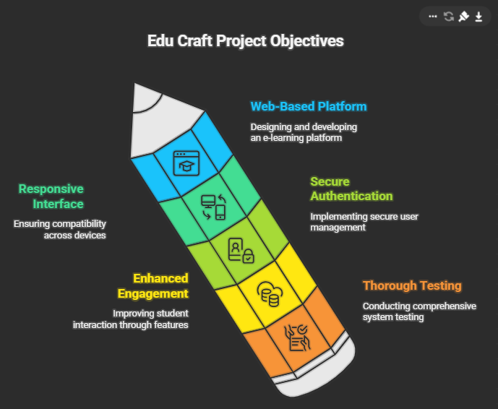
1.4 Objectives of the Project

1.5 Scope and Limitations
Scope:
- Provides a unified platform combining videos, notes, and quizzes.
- Allows role-based access, where teachers can create content and students can learn interactively.
- Ensures data security through authentication and controlled permissions.
- Scalable system architecture allows future inclusion of AI-based recommendations and analytics.
Limitations:
- The platform currently operates on web browsers only; a mobile app version is under consideration.
- Real-time collaboration is limited to note-sharing and does not yet include live streaming.
- Performance depends on stable internet connectivity for video streaming.

2. Literature Review / Theoretical Background
2.1 Overview of Web Development
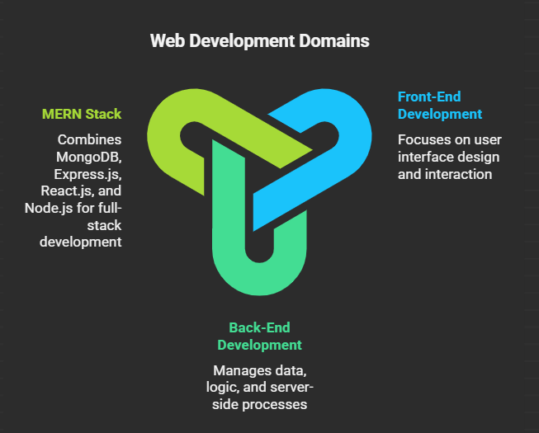

Edu Craft combines both aspects using the MERN stack (MongoDB, Express.js, React.js, Node.js), providing a full-stack JavaScript environment.
2.2 Front-End vs Back-End Technologies
S.No | Aspect | Front-End | Back-End
1 | Function | User interface and experience | Data handling and logic
2 | Languages | HTML, CSS, JavaScript | JavaScript (Node.js)
3 | Frameworks | React.js, Angular, Vue.js | Express.js
4 | Database Interaction | API Calls | MongoDB Queries
5 | Execution | Runs in browser | Runs on the server

2.3 Popular Front-End Frameworks
- React.js: Developed by Facebook, uses component-based architecture and virtual DOM. Ideal for dynamic UIs.
- Angular: Developed by Google, based on TypeScript and supports the MVC pattern.
- Vue.js: Lightweight, flexible, and easy to learn, suitable for small projects.

2.4 Comparison of Frameworks
S.No | Feature | React.js | Angular | Vue.js
1 | Language | JavaScript (JSX) | TypeScript | JavaScript
2 | Architecture | Component-based | MVC | MVVM
3 | Performance | High | Moderate | High
4 | Learning Curve | Moderate | Steep | Easy
5 | Flexibility | High | Medium | High
React.js was chosen for this project for its flexibility, high performance, and community support.
3. Methodology
3.1 Project Type – Experimental
The project follows an experimental iterative development approach based on the Agile methodology.
3.2 Tools and Technologies Used
S.No | Component | Technology / Tools | Purpose
1 | Front-End | React, React Router, Axios, CSS, Hooks | Build UI, handle routing & API calls
2 | Back-End | Node.js, Express.js, Mongoose, Passport.js | Server logic, APIs, and authentication
3 | Database | MongoDB | Store user & project data
4 | Tools | VS Code, npm | Development & debugging

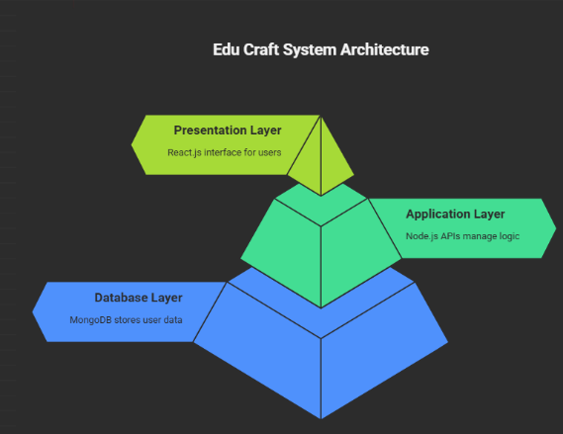
3.3 System Architecture / Project Design

This design supports modularity and scalability, making future upgrades and integrations easier.

3.4 Module Description
- Authentication Module: Manages user registration and login using JWT authentication.
- Course Management Module: Allows educators to upload, edit, and delete video lessons.
- Quiz Module: Enables interactive quizzes for student self-assessment.
- Notes Module: Allows students to upload and share notes collaboratively.
- Admin Module: Provides moderation and analytics capabilities for instructors.
3.5 Implementation Steps
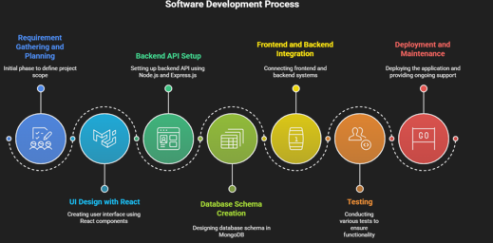

4. Results and Discussion
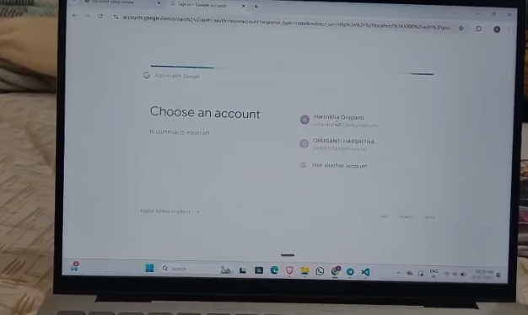
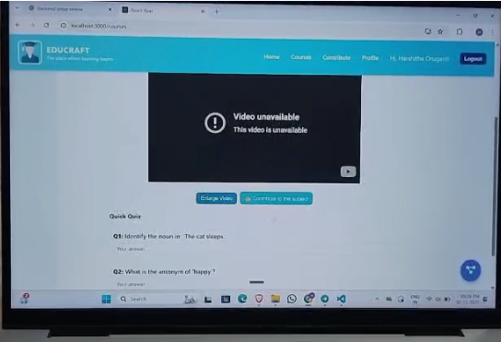
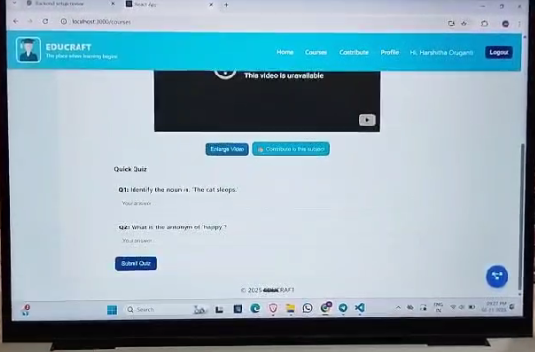
4.1 Screenshots of Implemented Interface
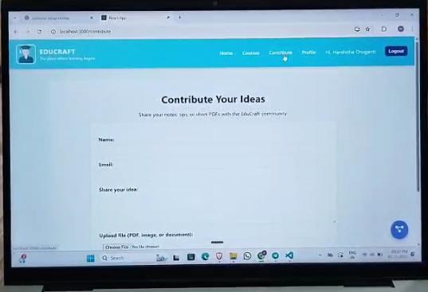
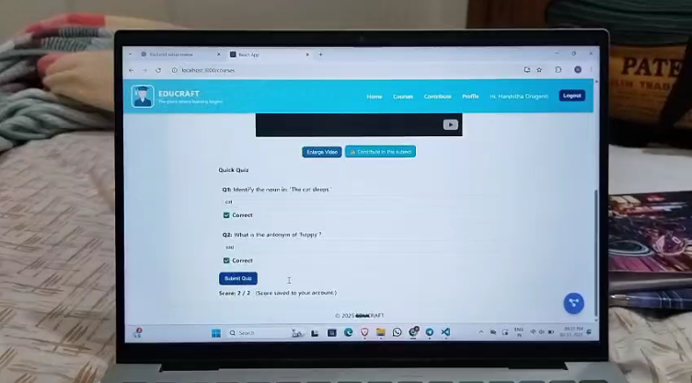
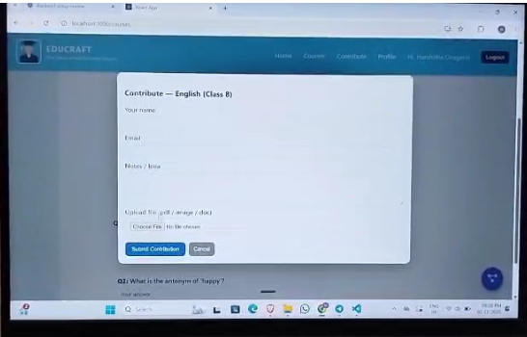
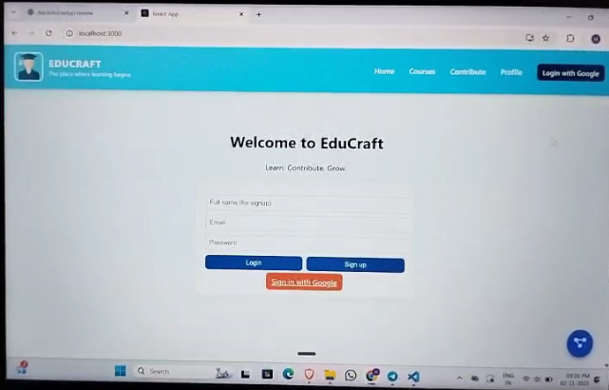
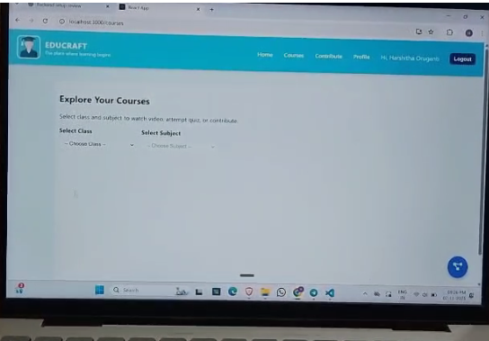

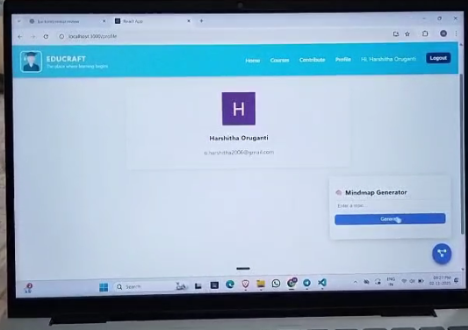
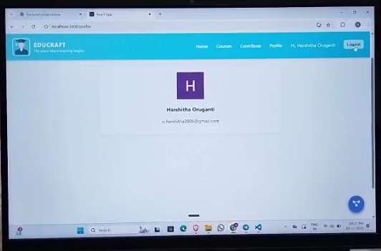
4.2 Output Format
Here’s the visual path :
- Login Account
- Open Dashboard
- Explore and Select Courses
- Access Study Videos
- Contribute Notes or Important Information
- Write a Quick Quiz
- Submit the Quiz
- Share Individual Ideas
- Use the Mind Map Generator
- Logout
4.3 Performance / Responsiveness Testing
S.No | Test Parameter | Observation
1 | Average API Response Time | 1.3 seconds
2 | Browser Compatibility | Works on Chrome, Edge, Firefox, Safari
3 | Device Compatibility | Fully responsive (mobile/tablet/desktop)
4 | Crash Reports | None observed

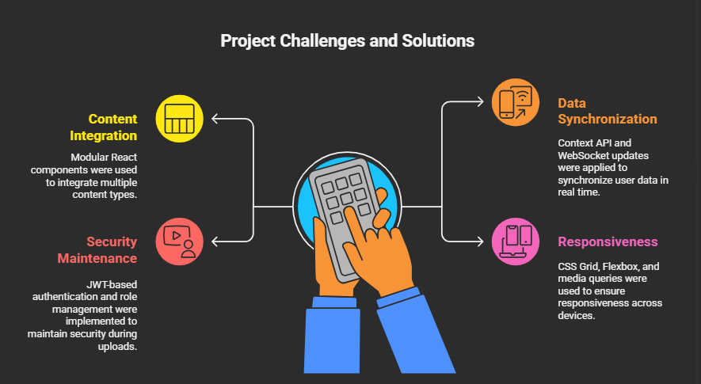
4.4 Challenges Faced and Solutions

5. Conclusion and Future Work
5.1 Summary of the Work Done
Edu Craft successfully integrates the essential components of e-learning, including videos, quizzes, and collaborative notes, into a single interactive web application. Built with the MERN stack, it provides an intuitive and secure environment for both educators and learners.

5.2 Key Findings
- Front-end frameworks significantly enhance development efficiency and user engagement.
- The combination of React.js, Node.js, and MongoDB provides flexibility and scalability.
- Responsive design ensures cross-platform accessibility and a consistent user experience.

5.3 Limitations
- Limited AI-based personalisation at present.
- Mobile app version yet to be implemented.
- Dependence on a stable network for video streaming, along with uploading notes or writing quizzes
5.4 Future Enhancements
- Integration of AI-driven recommendations for personalized learning.
- Development of mobile app and PWA for offline access.
- Real-time collaborative editing tools.
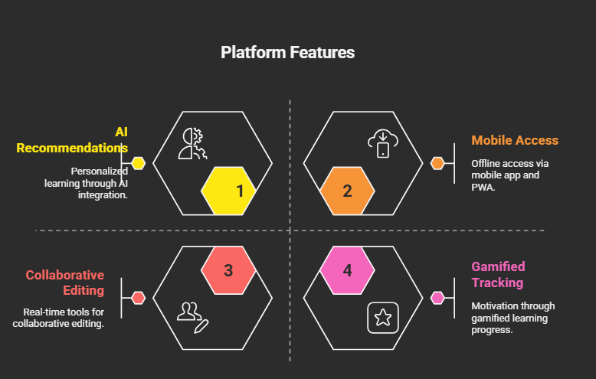
- Gamified learning progress tracking for enhanced motivation along with a gratitude wall to express

References
- Gupta, A., & Sharma, R. (2022). Interactive E-Learning Systems and Their Impact on Learning Outcomes.
- Park, J. (2020). Video-Based Learning and Student Engagement in Online Education.
- Brame, C. J. (2016). Effective Educational Videos: Principles and Guidelines for Maximising Student Learning.
- Giannakos, M. N., et al. (2021). Systematic Review of E-Learning Practices.
- Dahlan, M. B., et al. (2023). Exploring Interactive Video Learning: Techniques and Applications.

Appendices

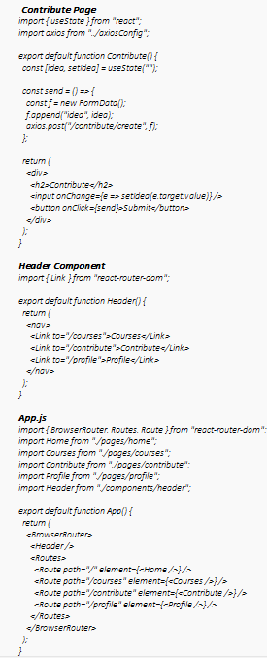
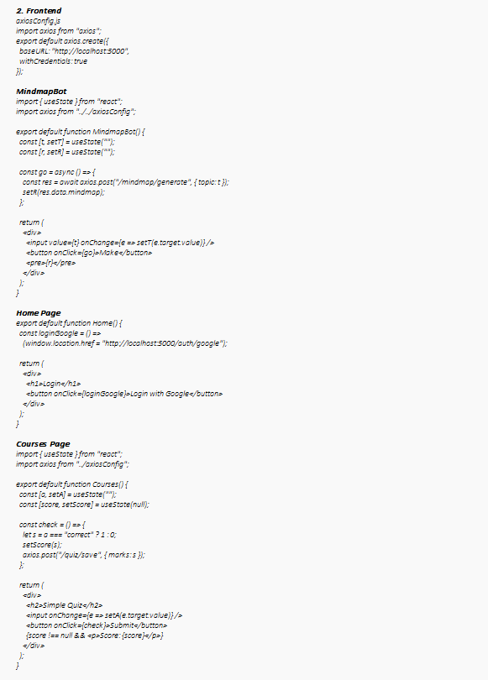
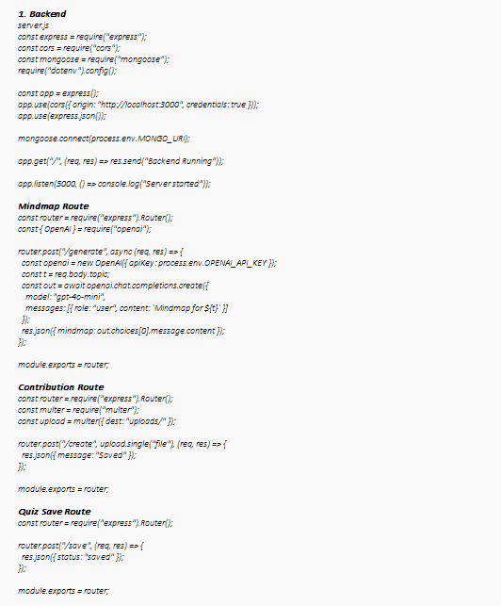
1) Source Code Snippets

2) User Manual/Installation steps
Login / Signup
- Login using:
- Google
- Email/Password
Courses Page
- Select Class (6–10)
- Select Subject
- Watch YouTube lessons
- Attempt quizzes
- Score automatically saved
Contribution Page
- Enter name, email, idea
- Upload a file if needed
- Submit to backend
- Stored in Contribution collection
Mind map Bot
- Floating button (bottom right)
- Enter any topic
- AI generates a mind map
- Saved to backend
Profile Page
- Shows:
  - Name
  - Email
  - Google picture
- Logout option available
3) Additional Data

Test Case | Expected Output | Result
Login | User Dashboard | Pass
Video Upload | Stored & Listed | Pass
Quiz Attempt | Shows Score | Pass
Notes Sharing | Accessible to Peers | Pass

